Stage 1:

- Design document with all diagrams – Use cases, ER diagram, sequence diagram, storyboards

Use Case Diagram:

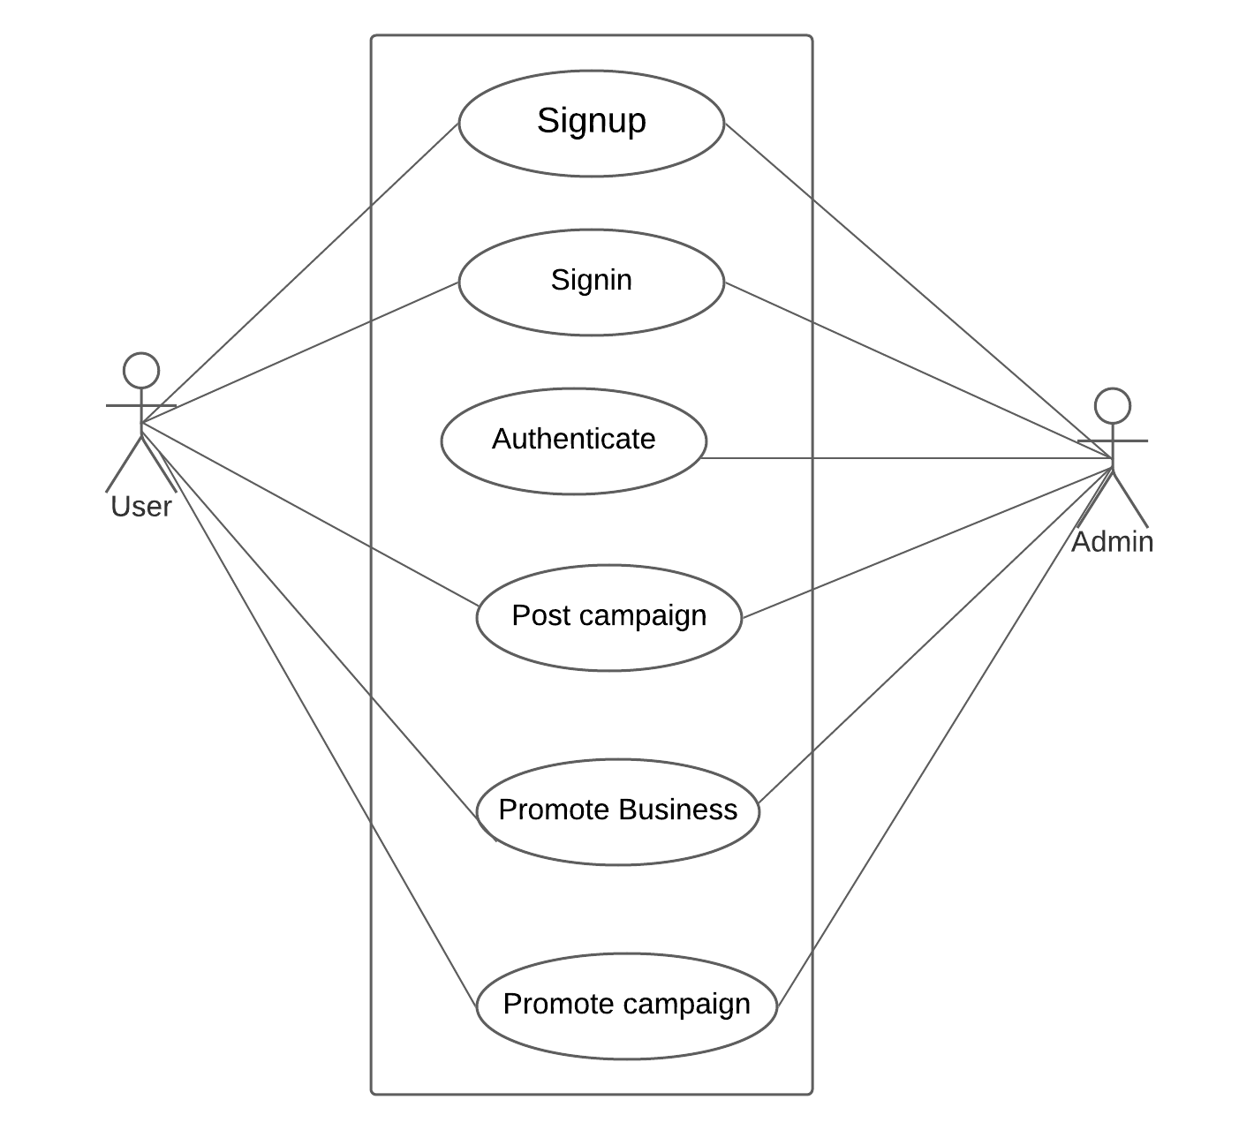

Sequence Diagram:
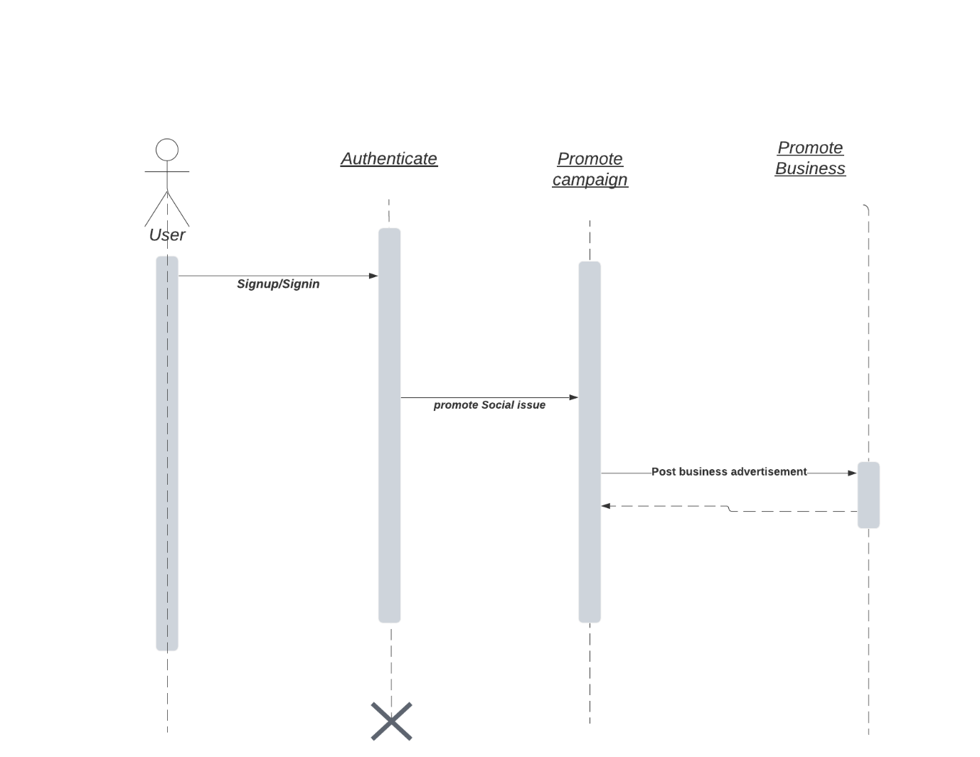

E-R Diagram:

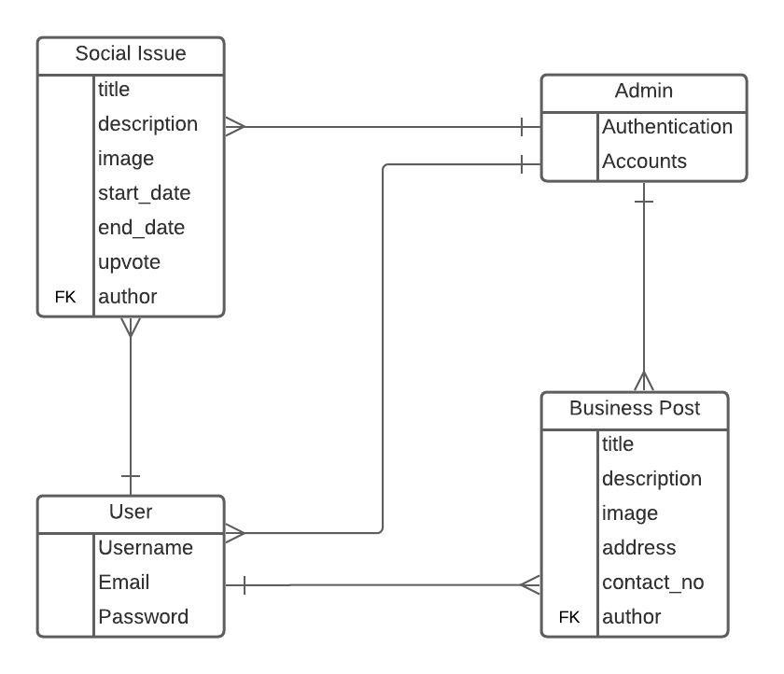

Data Flow Diagram:

Logout
Login
Promote Business
Add Campaign
Admin
User

Storyboard:

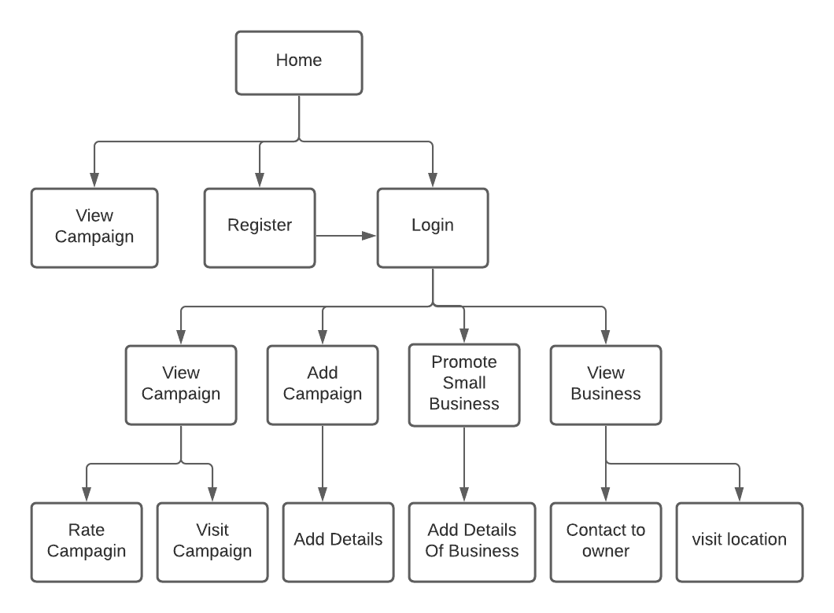
Web Design Standards:

- Logo is in the top left: Logo of the web site fix in the header. Which have a tree shape with the company name. click on the logo it will land us on home page.
Background-colour: #ffffff;
Hight: 70px;
Font-weight: 400

- Content in the top right: in the top right of the header, we fix a person icon in which we give login and registration functionality in website. By clicking it we will land on the login and registration form.
Width: 35px
Height: 70px;
Font-size: 1.5 rem

- Home page slide box: on the body of home page, we have shown the campaign exists on the web site by forward and backward navigation we can control and view all the campaigns. Below that slideshow we have a description bob in which we have reviewing the content about the campaign.
Slideshow image:
height: 400px
width:100%
Body font-family: sans-serif
Description box:
Heading:
font- family: sans-serif
Colour: #993366
Font-size: 2 rem
Content:
Font-size: 1.1 rem
Font-weight: 500
font- family: sans-serif

- Login page: on the login page we route by clicking the top right icon of the person. A login and registration form will appear.
Background: #ffffff
Boarder radius:15px
Login heading:
heading: H3
line height: 1
font-size: 1.5 rem
font-weight: bold
login button:
font-size: 0.9 rem
background colour: #3f51b5
colour: #fff
font-weight: 500
border radius:4px
same is for registration button as well.

- Prototype 1 with following requirements implemented.

- Home Page with campaign:

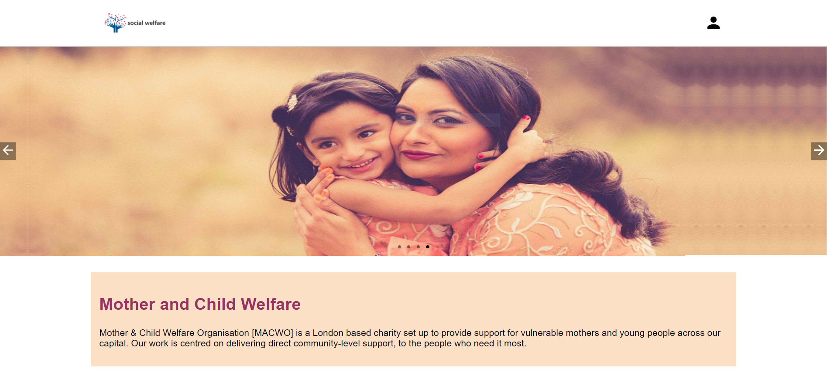

- Registration of new account:

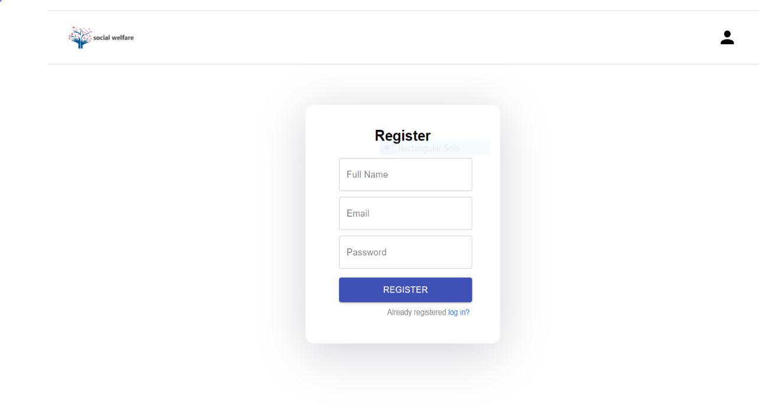

- Login:

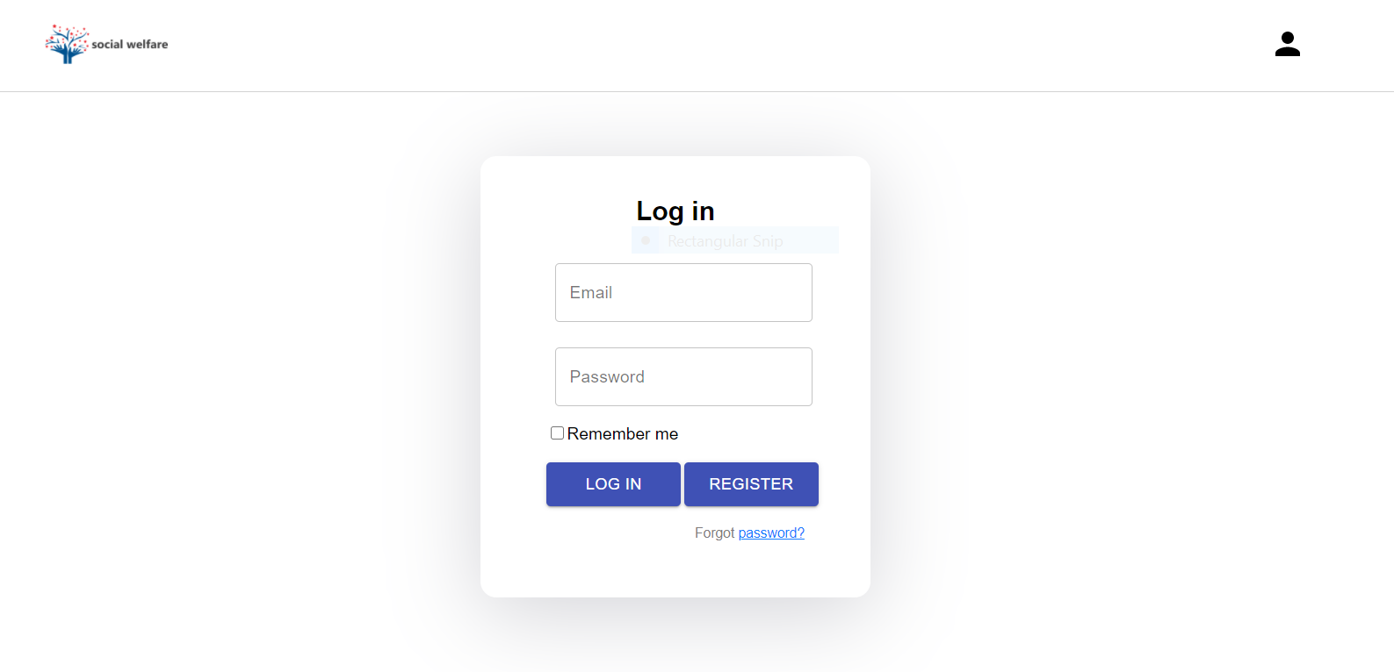

Source Code of Prototype:

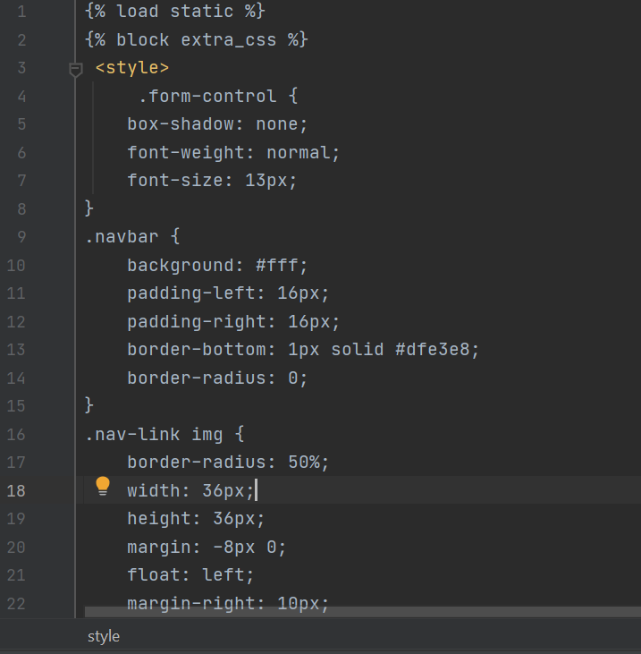

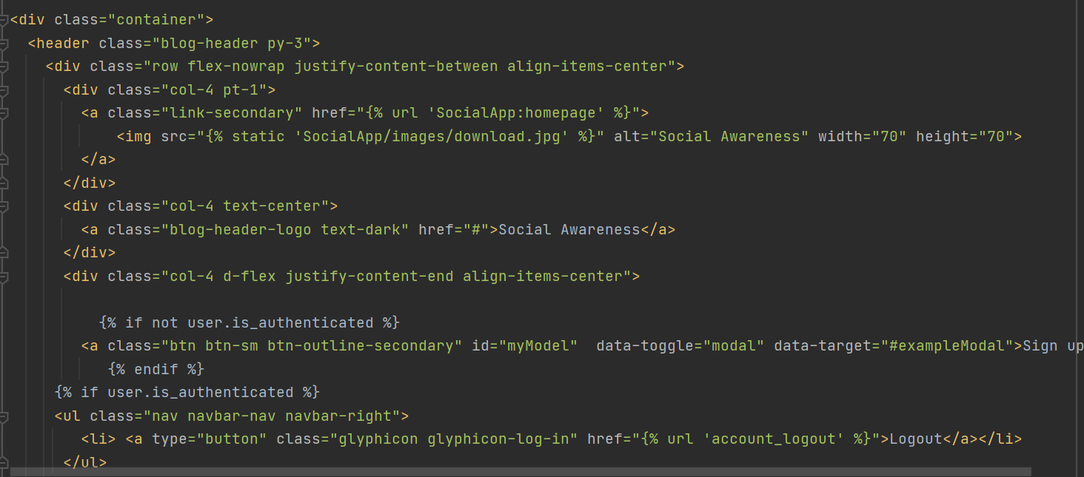

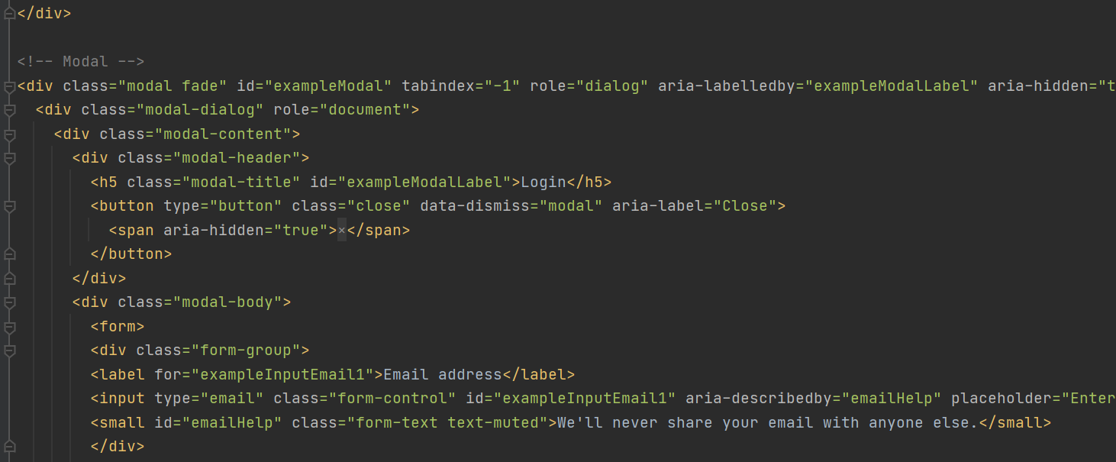

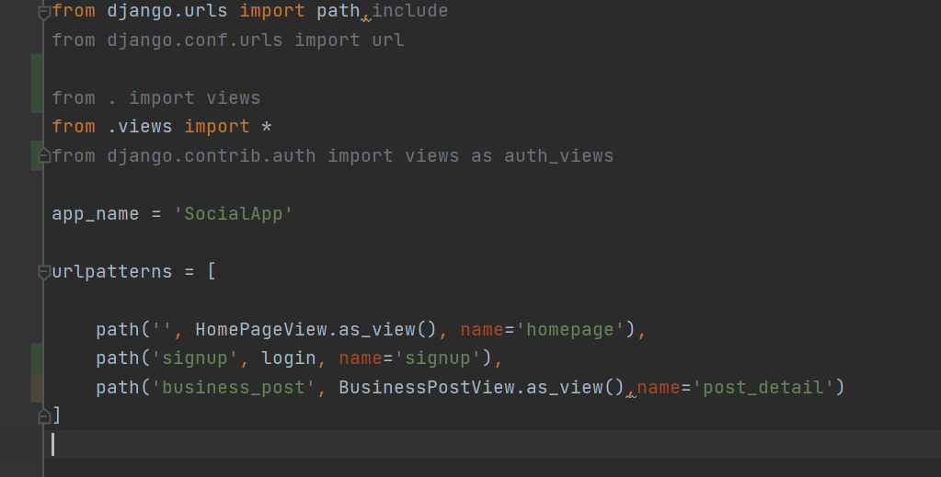

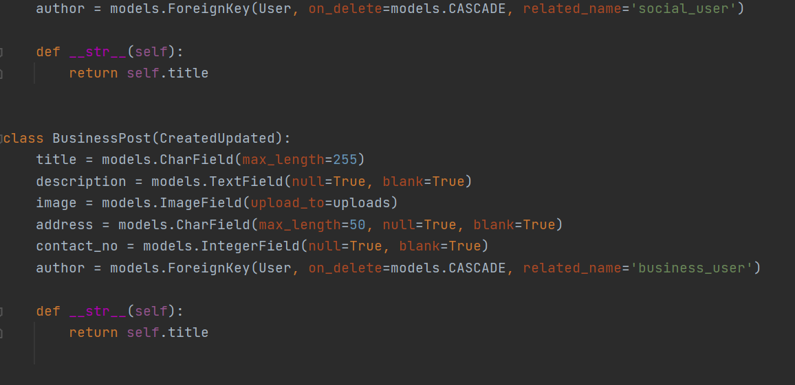

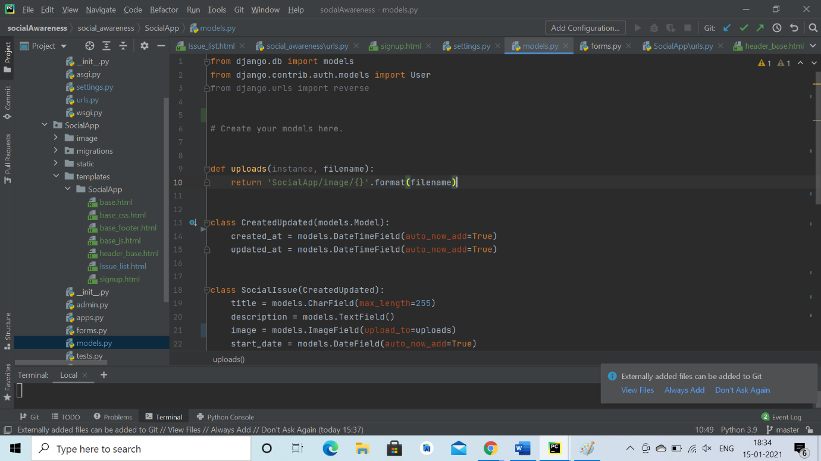

Website design test cases:

There are some factors by which we have to test the web site which are as follows:
- we have to check the image of the web page that are displayed properly or not.
- We have to verify clickable links and the buttons as well properly.
- Also we have to check the input and text fields that it enters data and is display properly or not on web page.
- Check the content of the page that are display accurate on all resolutions.
- Check the navigation button on the slideshow that it works on the web page forward and backward as well.
- Check that user is able to click on the clickable links or not.
- To verify that the login an register button is submitting the form or not.
- To verfiy that the slideshow image changes properly with to the navigation button and the content associated with it.
- Check all the images, font size and font type are displaying accuratly and consistent or not.
- Make sure that the form fields are display consistent on the web page or not.
- Ensure that the heading of the content on web page is display properly or not as defined in the code in every resolution.
- Check all the padding elements on the web page.
- Also check all the ui funtionality is coorect or not.

